**Module 3**

**Exercises**

1. Define a class named "Person" with attributes "name", "age", and "gender". Define a method called "introduction" which returns a string introducing the person. Create an instance of the class and call the class "introduction" method.

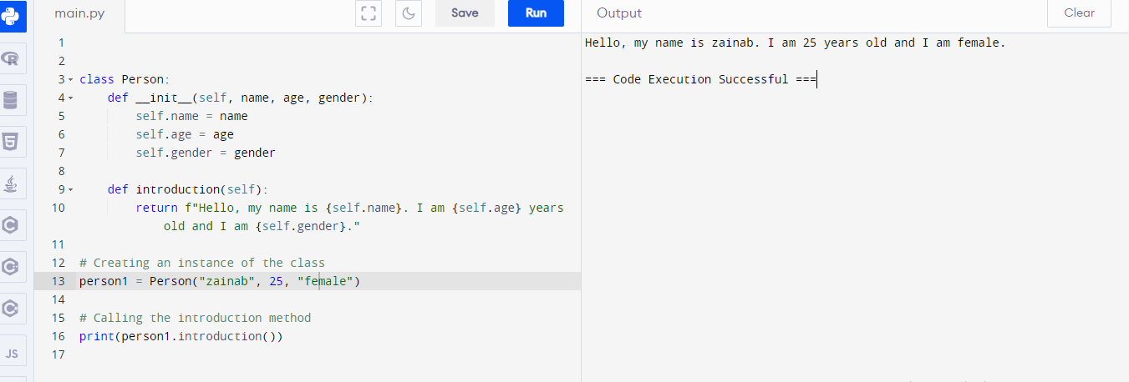

2. Define a class named "Rectangle" with attributes "length" and "width". Define methods "area" and "perimeter" which return the area and perimeter of the rectangle respectively. Create an instance of the class and call both methods

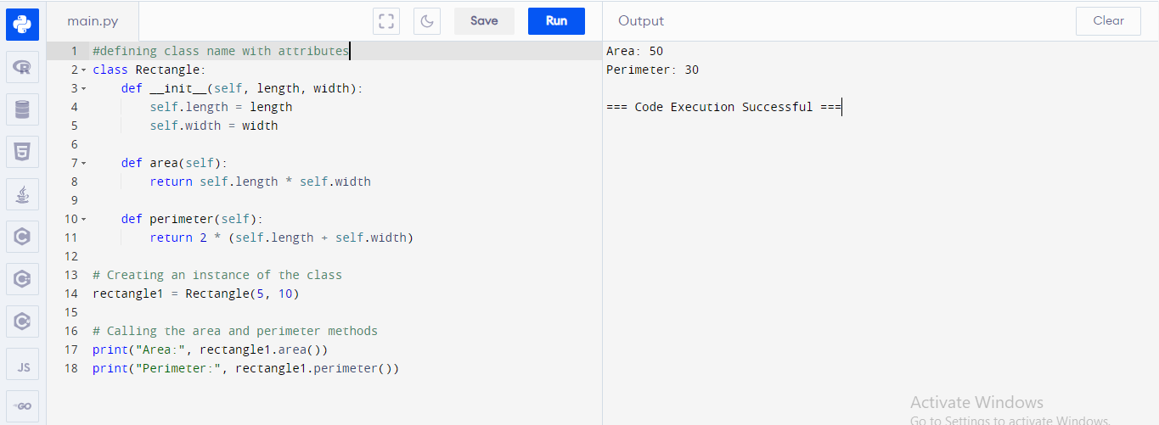

3. Define a class named "Student" with attributes "name", "age", and "grades". Define a method "average_grade" which returns the average of the grades. Create an instance of the class and call the method.

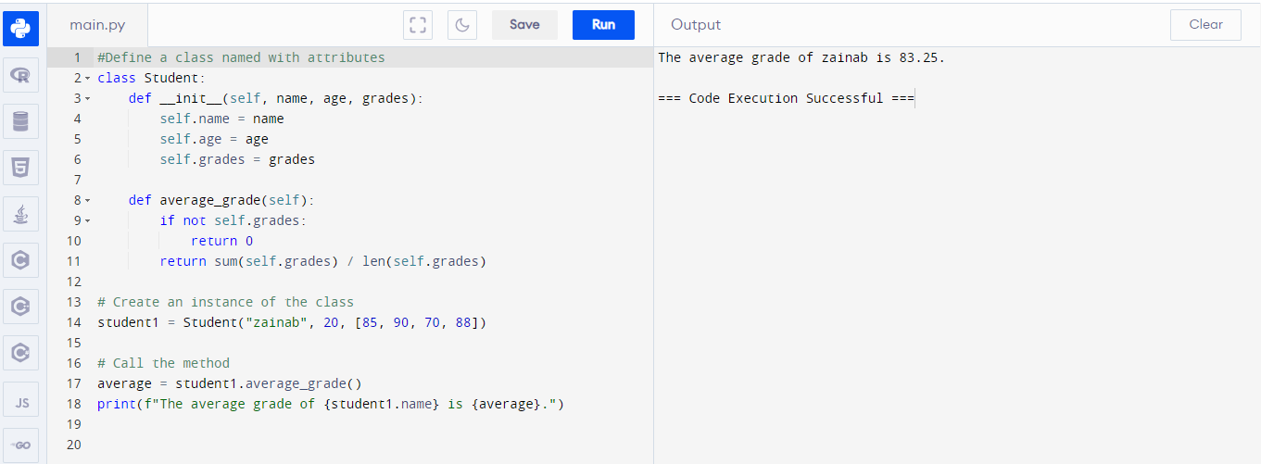

4. Create a base class called Animal with a method called make_sound() that prints "Animal making noise". Then create two subclasses Dog and Cat that both inherit from Animal . Override the make_sound() method in both subclasses to print "Woof" for Dog and "Meow" for Cat .

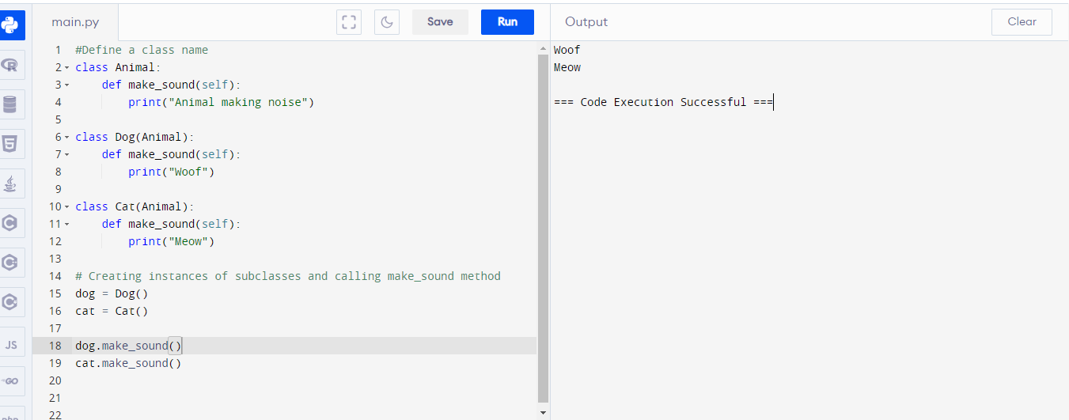

5. Create a class Rectangle with methods to calculate the area and perimeter. Then create a class Square that inherits from Rectangle . Override the methods in Square to only use one side length as the width and height.

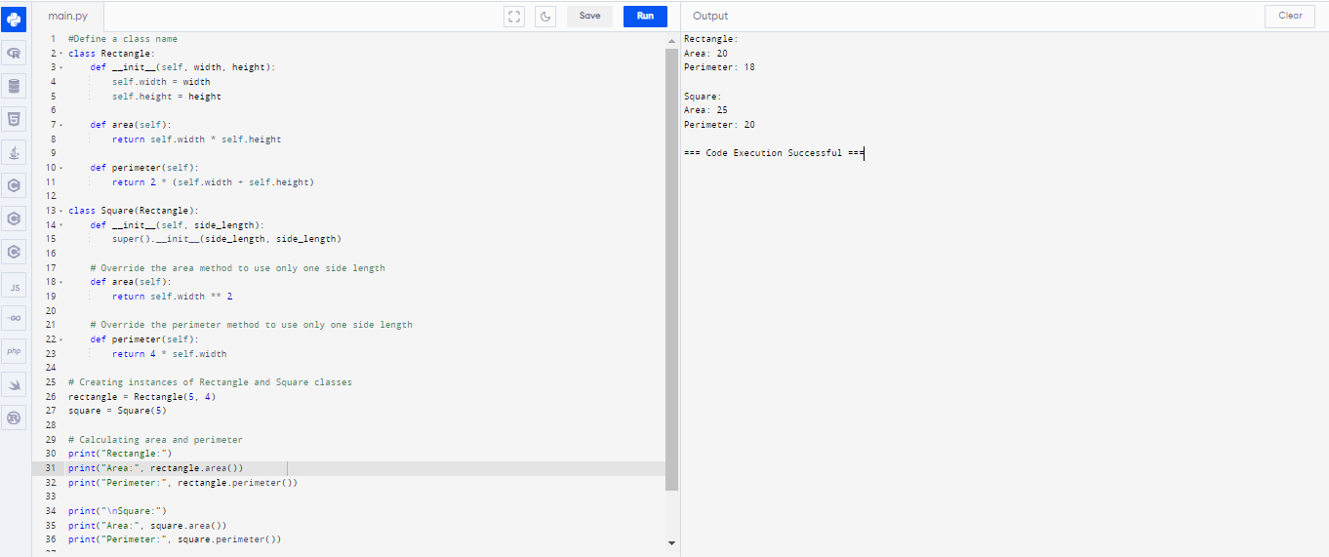

6. Create a class Person with attributes name and age . Then create a subclass Student that inherits from Person . Add an attribute student_id to the Student class. Override the __str__ method in both classes to return a custom string representation of each class.

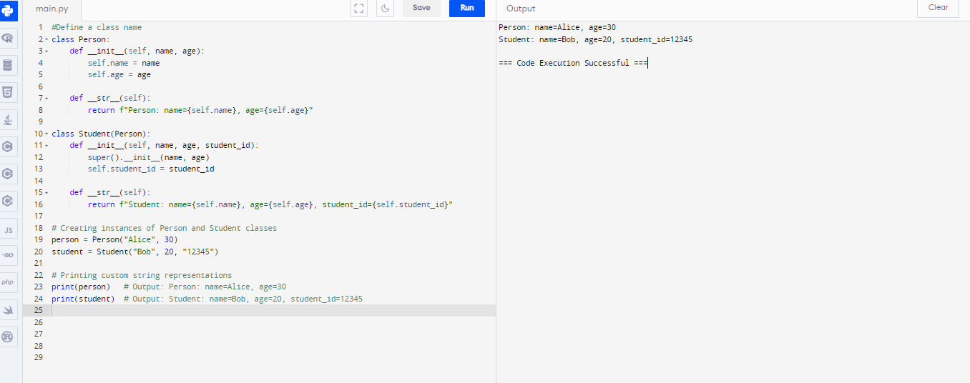

7. Write a function to divide two numbers. If the denominator is 0, raise an exception with the message "division by zero error".

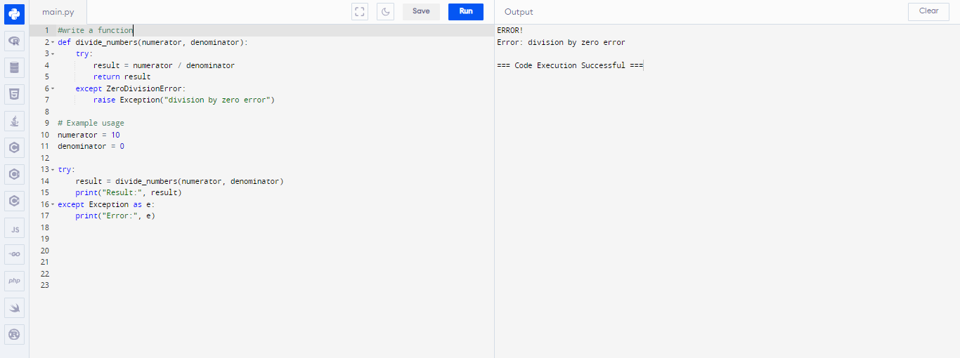

8. Write a function to calculate the square root of a number. If the number is negative, raise an exception with the message "negative number error".

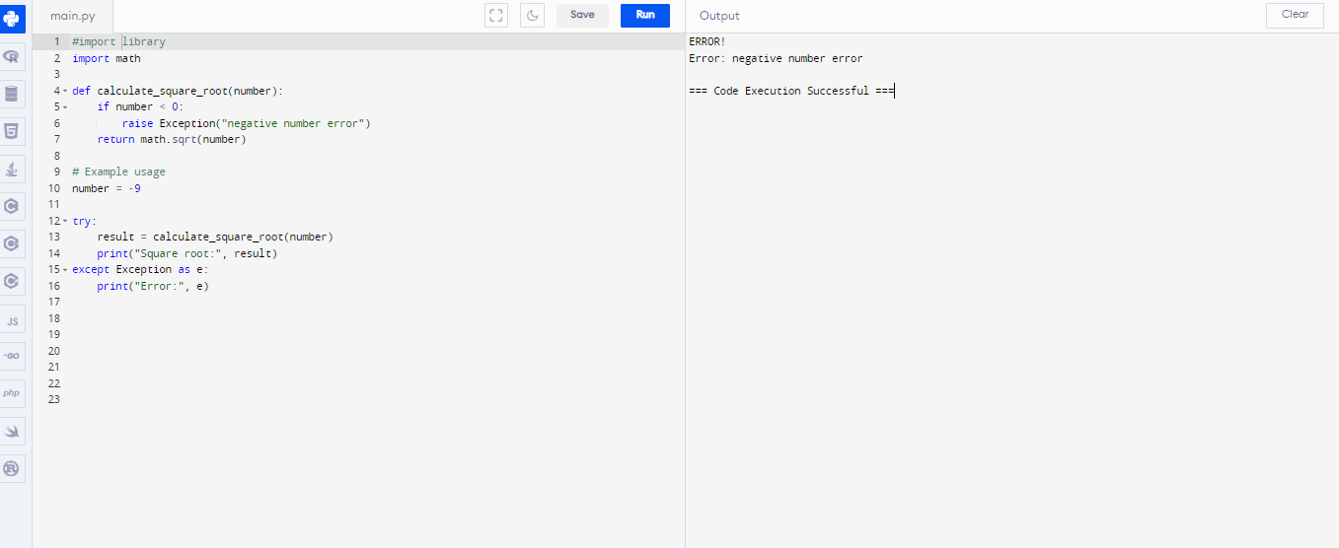

9. Write a function to read a file and count the number of lines in it. If the file does not exist, raise an exception with the message "file not found error".

